
Course: AG-NR-03.411 Natural Resources Management
Unit 3: Ecosystems

Lesson 2: Ecosystems of the United States and Their Management

Georgia Performance Standards: AG-NR-3
ACADEMIC STANDARDS: ELA9LSV1, ELA9LSV2, SCSh2, SCSh9, SEV3, SEV4, SEV5, SSWG1

Objectives:
1. Locate and describe the ecosystems within the United States.
2. Describe how environmental (abiotic) factors influence the location of ecosystems.
3. Describe how ecosystems are impacted by human activity.
4. Explain how sustainable and multiple-use management approaches can help maintain ecological balance in ecosystems.

Teaching Time: 2 hours

Grades: 9-12

Essential Question: What are features of different ecosystems in the United States?

Unit Understandings, Themes, and Concepts:
Students will learn about the different ecosystems in the United States, as well as the features of each. Students will gain an understanding of how humans impact ecosystems and conserve them with various management approaches.

Primary Learning Goals:
Students will be able to locate and describe ecosystems within the United States. Students will also be able to explain the impact humans have on these ecosystems and how various management approaches help maintain ecological balance.

Students with disabilities: For students with disabilities, the instructor should refer to the individual student's IEP to insure that the accommodations specified in the IEP are being provided within the classroom setting. Instructors should familiarize themselves with the provisions of Behavior Intervention Plans that may be part of a student's IEP. Frequent consultation with a student's special education instructor will be beneficial in providing appropriate differentiation within any given instructional activity or requirement.

Assessment Method/Type:
____ Constructed Response ____ Peer Assessment
_X__ Combined Methods ____ Selected Response
____ Informal Checks ____ Self Assessment

References:
The National Council for Agricultural Education. Applied Environmental Science. Alexandria, VA. 1996.
Materials and Equipment:
See reference materials.

PowerPoints:

Web Resources:
Map of Ecosystem Provinces
http://www.fs.fed.us/land/ecosysmgmt/colorimagemap/ecoreg1_provinces.html

Georgia Performance Standards:
AG-NR-3. Students will identify basic components of ecosystems, describe the relationship of those components to one another, and identify effects of human activities on ecosystems.

a. Define the elements and concepts of ecosystems.
b. Describe how ecosystems are impacted by human activity.
c. Describe and explain the elements and concepts of a forest ecosystem.
d. Describe how the concepts of sustainability and multiple uses can help maintain Georgia’s forest ecosystems.
e. Explain water cycles and describe aquatic ecosystems.
f. Identify types of wetlands and explain how they are impacted by human activity.

Academic Standards:
ELA9LSV1 The student participates in student-to-teacher, student-to-student, and group verbal interactions.

ELA9LSV2 The student formulates reasoned judgments about written and oral communication in various media genres. The student delivers focused, coherent, and polished presentations that convey a clear and distinct perspective, demonstrate solid reasoning, and combine traditional rhetorical strategies of narration, exposition, persuasion, and description.

SCSh2 Students will investigate the flow of energy and cycling of matter within an ecosystem and relate these phenomena to human society.

SCSh9 Students will enhance reading in all curriculum areas.

SEV3 Students will describe stability and change in ecosystems.
SEV4 Students will understand and describe availability, allocation and conservation of energy and other resources.

SEV5 Students will recognize that human beings are part of the global ecosystem and will evaluate the effects of human activities and technology on ecosystems.

SSWG1 The student will explain the physical aspects of geography.

Teaching Procedure

Introduction and Mental Set
If possible, show visual examples of each ecosystem type.
- Tundra • Coniferous Forest • Temperate Forest
- Grasslands • Deserts • Tropical Rain Forests
- Wetlands • Rivers, Lakes and Oceans

Discussion

1. What ecosystems are found in the United States and where are they are located?
A. Student Activity 1: Ecosystems of the United States- Blank Map. Using the blank map of the U.S., have students color in (using colored pencils) the different ecosystems found in the U.S.
1. Tundra: found in Alaska and high elevations on western mountains.
2. Coniferous Forest: Taiga (mountain forests) found in Alaska and high mountain elevations, Northern Coniferous Forest found in northeastern states.
3. Temperate Forests: Hardwoods found in east central and midwestern states, Swamp Forest found along the Mississippi and southeastern coastal rivers, and Mixed Conifer/Hardwood found in northeast, southeast, and western states.
4. Tropical Rain Forests: found in Hawaiian islands.
5. Grasslands: found in midwestern and western states.
6. Deserts: found in southwestern states.
7. Wetlands and 8. Aquatic: found in all states near water sources.
Eight ecosystems were selected to highlight in this lesson. Additional ecosystems representative of the local area may be added.
B. Have students research each ecosystem and make a chart showing the Description, Abiotic Factors and Typical Biota of each.

2. What environmental factors influence the location of ecosystems?
A. Environmental or abiotic factors are nonliving parts of the environment, including sunlight, water, climate, and soil that influence the location of ecosystems. Climate and water (the amount of precipitation or the character and depth of water) are important in determining the location of ecosystems.

The biotic or living communities in ecosystems are limited by these environmental factors and have adapted to particular climates and amounts of available water.
For example, desert plants have adapted to tolerating conditions with low rainfall, hot temperatures, and high rates of evaporation. The succulent nature of cactus, the hairs on its surfaces, and the burrowing and nocturnal habits of animals are all adaptations to conserve limited water resources and to avoid the effects of hot temperatures and high evaporative rates.
Another example is with the hardwood tree species that thrive in the warm, moist, sunny summers of the central and east central regions of the U.S. However, the cold temperatures of winter that freezes the ground and the reduced solar energy inhibit photosynthesis and the growth in these species. In response, hardwoods became deciduous (dropping leaves) which allows the tree to conserve moisture that would have been lost in exposed leave surfaces and produce a rich humus to build the soil (from fallen leaves) trees need during a growing season.

3. How does human activity impact ecosystems?
A. Using local ecosystem examples identified earlier, have students identify examples of how humans impact the ecosystem. Ask students how the impacts on the ecosystem have changed over time.
B. Transparency Master 1: Human Impacts on the Environment
People are part of the web of life. We are affected by the world around us and we affect the world by our actions. Early in human history, there were fewer people and they lived simply; human impact on ecosystems was minimal.

As people gradually changed from a hunting and gathering society to one that practiced agriculture and husbandry, human impact on the land increased. Human population increased, as a result of the more reliable food supply, along with it, deforestation, soil erosion, and overgrazing. Gradual degradation of the soil, water, forest and grasslands from these activities may have caused the downfall of great civilizations of earlier times.
The Industrial Revolution removed many people from direct contact with the land. As people concentrated in cities, they were separated from the land, no longer able to see the magnitude of their impact on the environment.

Examples of human impacts on the environment:
- Air pollution resulting from burning fossil fuels.
- Flooding and decreased water quality from the conversion of land and wetland for human use.
- Water pollution resulting from intense human use have increased the toxic metal and chemicals in industrial wastes, fertilizers, and pesticides in our waterways and groundwater.
- Human trash, waste, and sewage, improperly disposed of, enters our soils, waterways, and groundwater sources.
C. If time permits, students could collect local news articles about human impact on local ecosystems.

4. What are the concepts of sustainability and multiple use?
A. Transparency Master 2: Sustainability
Sustainability is human activity that does not degrade the earth's carrying capacity for future generations. There are three components to sustainable management:
1. Intergenerational fairness - balancing economic and
environmental needs of the present without compromising the ability of future generations to meet their need
Encourage students to find additional articles for up-to-date information on management approaches using the concepts of sustainability and multiple use.
2. Defining what is to be sustained - understanding the earth's resources and its interrelationships.
3. Knowing the scale of human impact on the environment - knowing the human impact relative to global environments ability to provide needed resources.

B. Transparency Master 3: Sustainable Agriculture
How could some of these activities be employed to reduce impacts on local ecosystems identified earlier in the lesson?
Sustainability usually refers to agricultural practices that focus on protecting the long-term condition of the soil rather than productivity. Components of sustainable agriculture include:
• Crop rotation
• Use of conservation tillage to build new topsoil and reduce soil erosion
• Conservation of irrigation water
• Careful and limited use of pesticides
• Use of nonfossil fuels (wind energy or solar power)

Sustainability can also apply to other human activities that affect the environment. Actions that can lead to a more sustainable lifestyle include:
• Control of population growth
• Use of technology to increase energy efficiency in homes, work places, and means of transportation
• Use of alternatives to fossil fuels such as solar, wind, or water power
• Reduction in waste of natural materials (metals, paper, plastics, etc.)
• Protection of soil and water by wise use of the land
• Reduction in consumption - change human behaviors

Multiple use is another important concept. It refers to using a resource for different uses at the same time. For example, forests have been managed to produce timber, protect wildlife habitat, and provide a place for human recreation. Wetlands have been used to process sewage, buffer water bodies, and provide wildlife habitat. Not all uses are compatible, but in many cases with careful planning, multiple uses may be made of the same ecosystem.
• Assign individual students or groups of students to an issue related to an ecosystem. Students should research all sides of the issue and present their findings to the class.
C. Transparency Master 4: Sustainable Lifestyles

Summary

The important factor in ecosystem management is one of value. Humans have valued productivity and space. Now, as we have learned how dependent we are on the health of our ecosystems; values are changing. Clean air and water and protecting our topsoil and the ecological balance in the ecosystems around us are becoming important and are challenging us to find new ways of living that will sustain our natural resources for us and for future generations. Knowledge and understanding about the complex elements of ecosystems and how those elements interact is essential to finding new, sustainable solutions to reducing harmful human impacts on the world around us.

Evaluation
Student assessment could be based on the projects and assignments completed during the lesson.

SA - 1
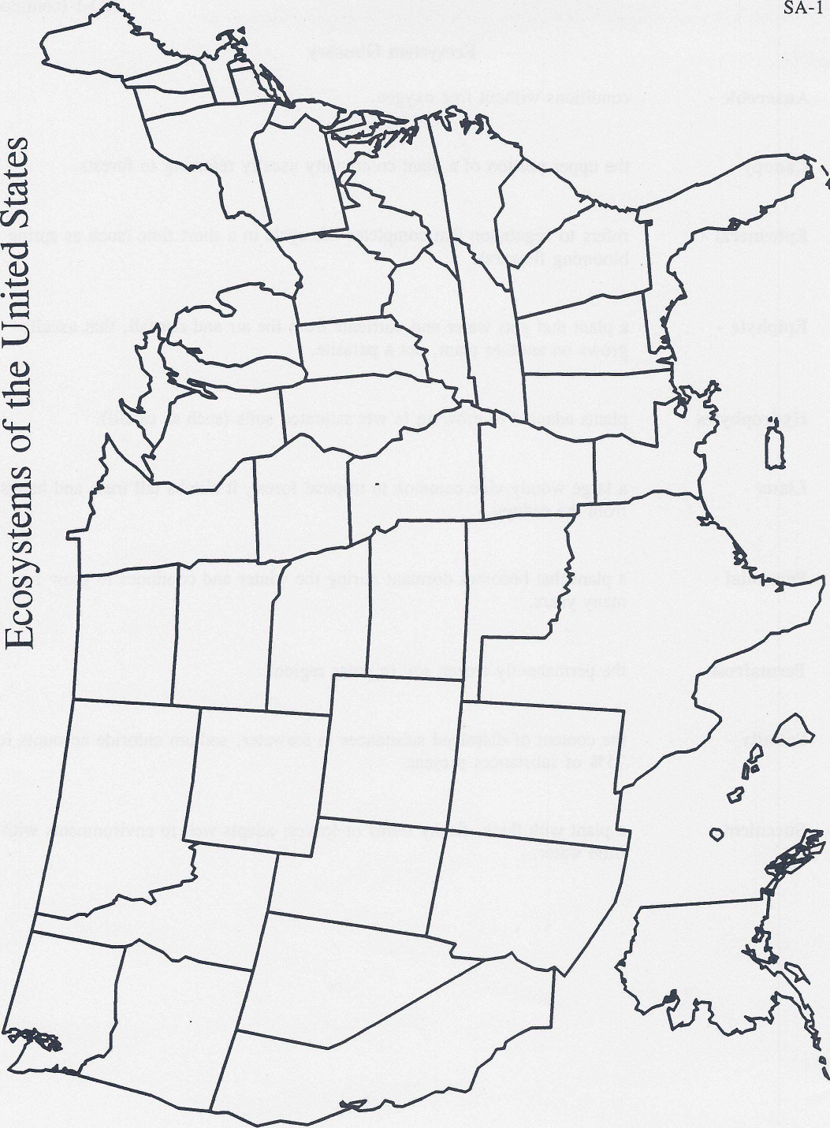
TM-1

Human Impacts
on the Environment
Air pollution
Additional flooding
Water pollution
Trash, waste, and sewage

TM - 2
Sustainability is...
human activity that does not degrade
the earth's carrying capacity for future
generations:
- Intergenerationa^{l} fairness
- Defining what is to be sustained
- Knowing the scale of human impact
on the environment

TM - 3
Sustainable Agriculture
- Crop rotation
- Use of conservation tillage to
build new topsoil and reduce
soil erosion
- Conservation of irrigation water
- Careful and limited use of
pesticides
- Use of alternative fuels (wind,
solar)
TM - 4
Sustainable Lifestyles
• Control of population growth
• Use of technology to increase
energy efficiency
- Use of alternative fuels
- Reduction in waste of natural
resources
• Protection of soil and water by
wise use of the land
• Reduction in consumption

Individual Learning Activity

Lesson: Ecosystems of the United States
Assignment: Choose one of the topics below and research it. Write a report on your findings that answers the question or explains the concept and shows why it is relevant to your life.

1. Locate and describe the ecosystems within the United States.
2. Describe how environmental (abiotic) factors influence the location of ecosystems.
3. Describe how ecosystems are impacted by human activity.
4. Explain how sustainable and multiple-use management approaches can help maintain ecological balance in ecosystems.
Minimum Requirements:

1. Paper must be typed in 12 point font and at least one page in length. The paper should be double-spaced.

2. At least two credible references must be properly cited.

3. All work must be original. No plagiarism! Any use of
another’s ideas without giving credit will result in a zero.

4. Papers will be graded on content (amount of good information, accuracy, etc.) and mechanics (grammar, spelling, and punctuation.)

Due Date:
Points/Grade Available:
Individual Learning Activity Rubric
Content - offers current information on the topic chosen, thoroughly covers each aspect of the question, and demonstrates understanding and mastery of the lesson. The paper should include information and issues of state and local importance. | 35 pts.
Critical Analysis - logical process of analyzing and reporting information that examines and explains the topic selected. The paper should go beyond simply listing facts and must include why the concept is relevant to the student’s life. | 25 pts.
Organization- The paper should have an orderly structure that demonstrates a logical flow of ideas. | 15 pts.
Mechanics- spelling, grammar, punctuation, font size, double spacing, citation, etc. Essentially, the paper should meet all specifications and be executed following rules of proper written English. | 15 pts.

Group Learning Activity

Lesson: Ecosystems of the United States
Assignment: Choose one of the topics below and research it. With your group, prepare a presentation to teach the class your concept.

1. Locate and describe the ecosystems within the United States.
2. Describe how environmental (abiotic) factors influence the location of ecosystems.
3. Describe how ecosystems are impacted by human activity.
4. Explain how sustainable and multiple-use management approaches can help maintain ecological balance in ecosystems.
Your presentation should include the following:
- A lesson plan outlining exactly what your group will teach and how the information will be taught
- A Power Point of at least twelve slides
- Notes containing the information for which the class will be responsible (these can be printed and given to the class, written on the board, or part of the Power Point). A copy of the notes will be turned in to the instructor.
- Some type of interactive activity for the class (game, problem solving activity, interactive model, etc.)
- Your group must also prepare an assessment for the class. This assessment can be written or oral, but should show the instructor that the class understands and has retained the material being taught.
Due Date:
Points/Grade Available:
All work must be original. No plagiarism! Any use of
another’s ideas without giving credit will result in a zero.
Group Learning Activity Rubric
Lesson Plan – The group submits a thorough, detailed lesson plan highlighting the content and organization of their lesson. | 10 pts.
PowerPoint – The group presents a Power Point of at least twelve slides that contains information and pictures vital to the lesson with additional information or examples for enhancement. | 20 pts.
Interactive Activity – Some type of interactive activity is used to help teach the lesson. The activity should contribute to the mastery of content and involve the entire class in some way. | 15 pts.
Assessment – A fair, thorough assessment is prepared and administered based on the information presented to the class. Poor grades on the assessment by a few members of the class are excusable, but if the entire class has difficulty, the points awarded in this category may be lowered at the discretion of the instructor. | 15 pts.
Content – The group should cover the concept (within reason) in entirety. The group may study actual lesson plans to help decide what should be emphasized. | 25 pts.
Overall Effect – The group is prepared, enthusiastic, and interesting, and the lesson flows smoothly. | 15 pts.

Presentation Learning Activity

Lesson: Ecosystems of the United States
Assignment: Choose one of the topics below, research it, and prepare a presentation that answers the question or explains the concept and shows why it is relevant to your life.

1. Locate and describe the ecosystems within the United States.
2. Describe how environmental (abiotic) factors influence the location of ecosystems.
3. Describe how ecosystems are impacted by human activity.
4. Explain how sustainable and multiple-use management approaches can help maintain ecological balance in ecosystems.

Minimum Requirements:
Oral Report Option
1. Write a paper on one of the topics and orally present your work to the class.
2. Paper may be double-spaced and should be at least one page in length, resulting in a two to five minute presentation.
3. At least two references must be properly cited.
4. The presentation of the report will be graded secondary
to the content of the paper.
PowerPoint Option
- Presentation should be at least ten slides in length
- Presentation should include at least four photos.
- Presentation should be two to five minutes in length.
- Grammar and spelling will be graded by the same standards as any other written assignment.
- At least two references must be properly cited.
Poster Option:
- Prepare a poster that answers/explains one of the topics. You will present your poster to the class.
- Your poster should include both text and graphics that help communicate your research.
- At least two sources of information should be properly cited on the back of the poster.
- Neatness and appearance of the poster will be graded.
- Poster presentation should last two to five minutes.

Due Date:

Points/Grade Available:

For all presentations: All work must be original. No plagiarism! Any use of another’s work or ideas without giving proper credit will result in a zero.

Presentation Learning Activity Rubric

Content- offers current information on the topic chosen, thoroughly covers each aspect of the question, and demonstrates understanding and mastery of the lesson. The presentation should include information and issues of state and local importance. | 40 pts.
Critical Analysis/Organization – The presentation shows a logical process of analyzing and reporting information that examines and explains the topic selected. The presentation should go beyond simply listing facts and must include why the concept is relevant to the student’s life. | 20 pts.
Presentation – The student makes a genuine effort to present, not just read the material. The student should present with confidence using techniques like eye contact and voice inflexion to make his or her point. Although content takes precedence over presentation, the experience of successfully presenting in front of a class is part of the basis of this assignment. | 25 pts.
Mechanics- spelling, grammar, punctuation, font size, double spacing, citation, etc. Essentially, the presentation should meet all guidelines set forth and should be executed in proper written English. For the poster, this includes neatness and appearance. | 15 pts.

Teacher Notes

Essential Question: What are the features of different ecosystems of the United States?

